THE REAL SCHOOLS
LEARNER’S EMPOWERMENT ACTIVITY
P.5 TERM 1 2025 SOCIAL STUDIES
PHYSICAL FEATURES




Makindye Junior School

Golden Junior School

Victoria. A. Primary School

Approved by:
………....….
QC

Name: ________________________________ Class: __________
School: ________________________________Stream: _________
THEME: LIVING TOGETHER IN UGANDA
TOPIC: PHYSICAL FEATURES OF UGANDA
SUB TOPIC: RIVERS IN UGANDA
LEARNING OUTCOME: THE LEARNER IS ABLE TO EXPLORE, UNDERSTAND AND APPRECIATE THE VALUE OF ONE’S IMMEDIATE AND DISTANT ENVIRONMENT FOR BETTER HEALTH AND HARMONIUOS LIVING.
- BACKGROUND KNOWLEDGE
In primary four we learnt about physical features and grouped them into drainage and relief physical features. Under the drainage features we looked at rivers as a concept and in this sub topic we are going to learn rivers in details.
- RELEVANCE:
To enable the learner identify, locate and describe the main rivers in Uganda and explain their importance in daily life.
- INTRODUCTION
In this sub topic we are going to learn about
- Terms related to rivers.
- Stages of river development
- Examples of rivers and their descriptions
- Importance of lakes and rivers
- Convectional rainfall
- Problems associated with lakes and rivers
- Reasons why lake shores and river banks are highly populated
- The influence of physical features
- SESSION 6:
- RIVERS IN UGANDA
- RELEVANCE: To enable the learner identify, locate and describe the stages of river development and explain the importance of river Nile in Uganda.

- INTRODUCTION
In this lesson, we are going to learn about;
- Terms related to rivers
- Stages of river development
- River Nile
- COMPETENCES
- Describes terms related to rivers
- Describes the stages of river development
- Describes river Nile
- Explains why some parts of river Nile are not navigable.
- CONTENT
- Terms related to rivers.
A river source is a point where a river begins to flow.
A river mouth is a point where a river ends its flow.
A tributary is a small river that joins the main river.
A distributary is a small river that branches away from the main river.
A river confluence is a place where two or more rivers meet.
An estuary is a wide part of a river as it ends its flow.
A drainage basin is an area of land drained by a river, its tributaries and distributaries.
A flood plain is a flat area near a river that often floods when the water level rises.
A delta is the place where a river forms several streams as it ends its flow
Deltas are formed at the mouths of rivers, as a result of river deposition.
Deltas have rich fertile soil for crop growing.
They also attract tourists who bring in income.
A waterfall is a steep flow of a river.
Or. It is a point where a river flows from high altitude to a low altitude.
A Cataract is a series of waterfalls on a river.
Waterfalls attract tourists who bring in income, and also help in generation of
hydroelectricity.
However, waterfalls may cause water accidents and also block water transport.
- MINI ACTIVITY
1. Define the term estuary
___________________________________________________________________________
2. Name the place where river Nile starts its flow
___________________________________________________________________________
3. How do we call a series of waterfalls on a river?
___________________________________________________________________________
4. From which altitude does the river start its flow?
___________________________________________________________________________

5. Name any one tourist attraction on a river.
___________________________________________________________________________
Stages of River development
A river has three main stages/ courses.
These are;
The Youth stage/Upper course
The Old stage/ Lower stage (Senile) • The Mature stage/ Middle stage
Stage | Characteristics
The Upper course | - It has waterfalls and rapids  - The river flows very fast.  - It forms a V-shaped valley (gorge).  - The river flows over a steep slope.  - There is a lot of vertical erosion. Note:  - This stage is suitable for generation of hydroelectricity because it has many waterfalls.  - The upper stage is suitable for tourism because it has many waterfalls which attract tourists.
The Middle stage | - The river flows gently.  - It forms a U-shaped valley.  - There is lateral erosion in this stage.  - It begins to form meanders.
The Lower stage | - The river flows slowly.  - It forms meanders and ox-bow lakes.  - It forms a delta or an estuary.  - It forms alluvial plains.  - The river deposits its load forming flood plains.
- Features found along river valleys.
Waterfalls, Gorges , Deltas , Ox-bow lakes, Estuaries
- MINI ACTIVITY
1. Mention any two examples of features found on a river
i) ______________________________________ ii) _______________________________

2. Draw a map symbol of a waterfall in the space provided below

3. Give any two characteristics of a river in its lower stage
i) _________________________________________________________________________
ii) _________________________________________________________________________
4. In which stage of a river do waterfalls develop?
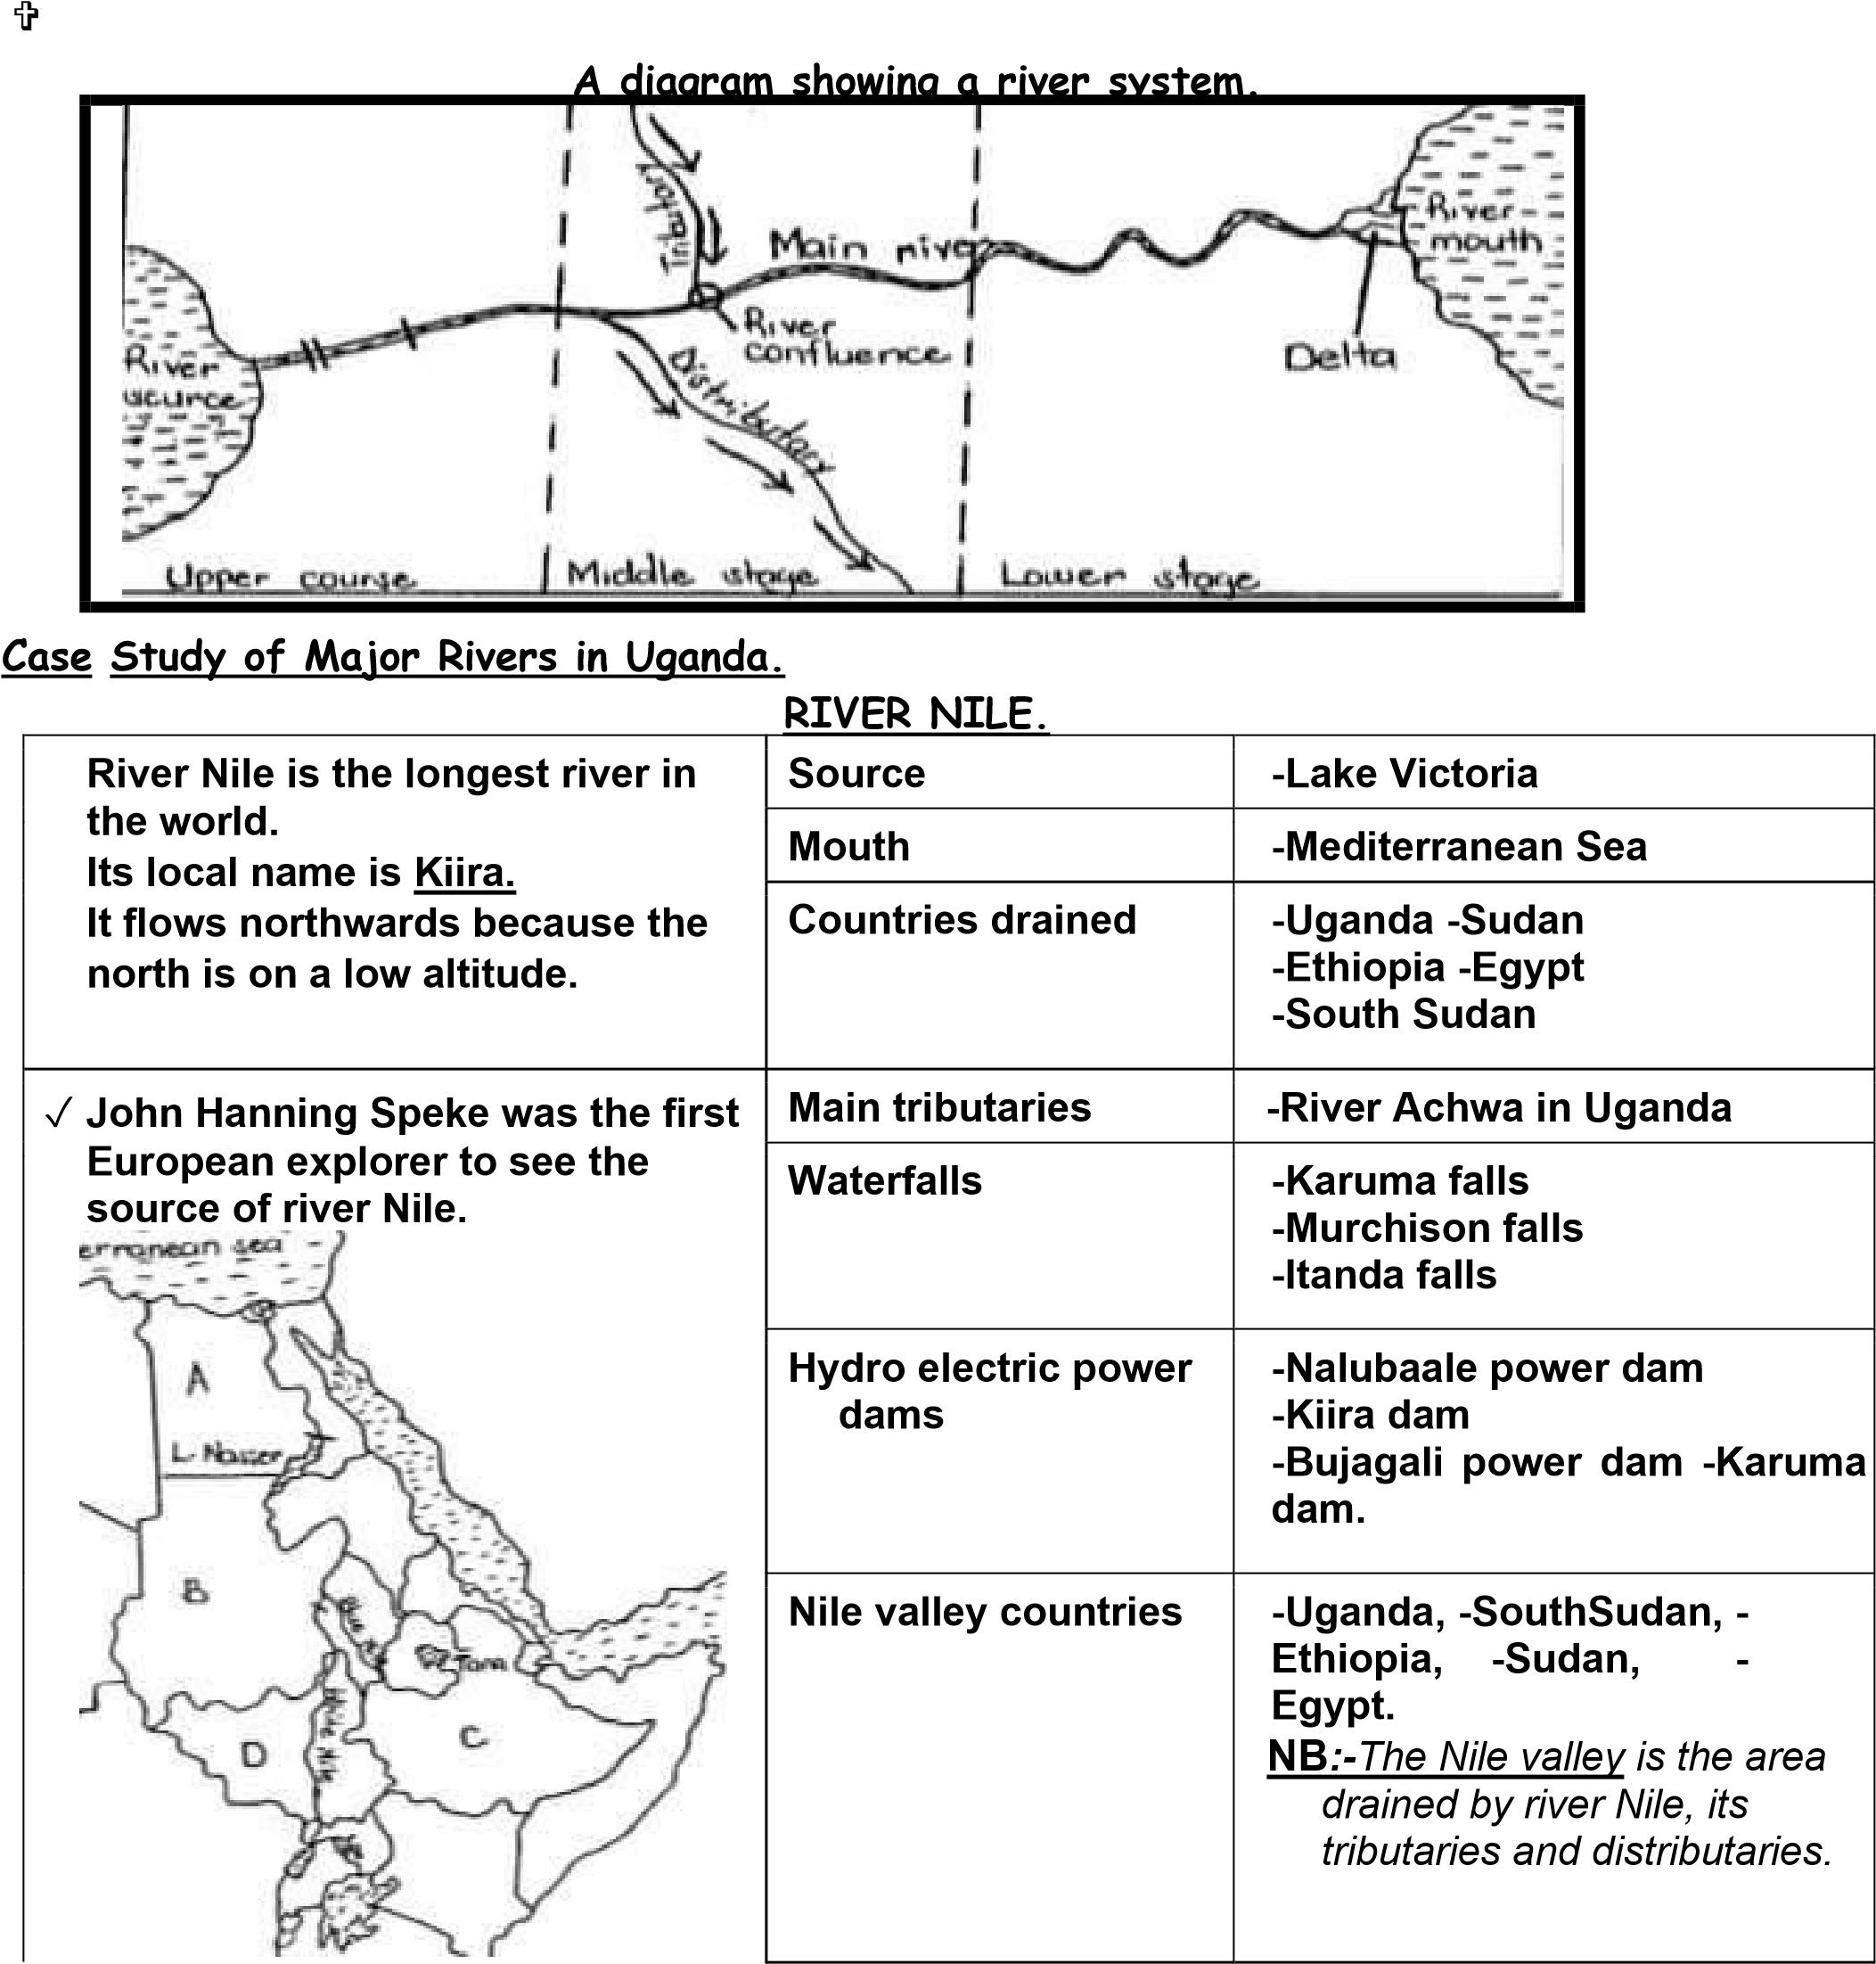
___________________________________________________________________________

- Reasons why some parts of River Nile are not navigable.
- Presence of waterfalls and rapids.
- Presence of floating vegetation/suds.
- Presence of dangerous aquatic animals.
- Some parts of river Nile are shallow and narrow.
- MINI ACTIVITY
1. Name the longest river in Uganda
___________________________________________________________________________
2. Draw a map symbol of a river in the space provided below.

3. Why do you think some parts of a river are not navigable?
___________________________________________________________________________
4. Name any two parts of river Nile in Uganda
i) ___________________________________ ii) ___________________________________
5. Why does river Nile start its flow from L. Victoria?
___________________________________________________________________________
KEY LEARNING PRINCIPLES
Stages- refer to phases or steps in a development or journey
Features- they can also be termed as characteristics or things found on something
Deposition- refers to the process of rocks being carried and dropped by natural
forces such as running water.
PROJECT WORK
Draw a map of Uganda showing the flow of river Nile and indicate its source.

List down the competences that have been hard for you.
1
2
3
4
5
6
7
8
9
- MEGA ACTIVITY
1. Define the term a river
____________________________________________________________________________
2. Give any two examples of rivers in Uganda
i) _______________________________________ ii) ________________________________
3. Why are some parts of river Nile not navigable?
____________________________________________________________________________
4. How are water falls economically important to the government of Uganda?
____________________________________________________________________________
5. Draw a map symbol of a waterfall in the space provided below

6. Mention the main tributary of river Nile
____________________________________________________________________________
7. Why is HEP generated from the first stage of a river?
____________________________________________________________________________
8. In which stage of a river is vertical erosion mostly appearing?
____________________________________________________________________________
9. Give any two characteristics of a river in each stage of a river
i) __________________________________________________________________________
ii) __________________________________________________________________________
10. Why does a river flow from a high altitude?
____________________________________________________________________________
SESSION 7 DESCRIPTION OF RIVERS
RELEVANCE: To enable the learner identify name and locate examples of rivers in Uganda and describe their sources, courses and importance to the country.

- INTRODUCTION
In the previous session, we have been able to learn about
- Terms related to rivers
- Stages of river development
- The case study of river Nile
- COMPETENCES
- Describes river katonga, kagera, kafu, semlik and achwa
- Explains activities carried out on and around lakes and rivers
- Explains the importance of lakes and rivers
- CONTENT
- River Katonga.
- It flows from lake George to lake Victoria.
- River Kagera.
- It forms a natural boundary between Uganda and Tanzania.
- It flows from highlands in Burundi to lake Victoria in Uganda.
- River Kafu.
- It flows from lake Albert to lake Kyoga.
- River Semliki.
- It connects lake Edward to lake Albert.
- It forms a natural boundary between Uganda and Democratic Republic of Congo. River Achwa.
  - It is the main tributary of River Nile in Uganda.
  - It joins river Nile near Nimule in South Sudan.
MINI ACTIVITY
1. From which country does river Achwa join river nile from?
___________________________________________________________________________
2. Why is the above river regarded as the major tributary of river nile?
___________________________________________________________________________
3. Which river connects lake Edward to lake Albert?
___________________________________________________________________________
4. What is the political importance of river kagera?
___________________________________________________________________________
5. Where is the source of river kagera found?
___________________________________________________________________________

THE SKETCH MAP OF UGANDA SHOWING LOCATION OF RIVERS
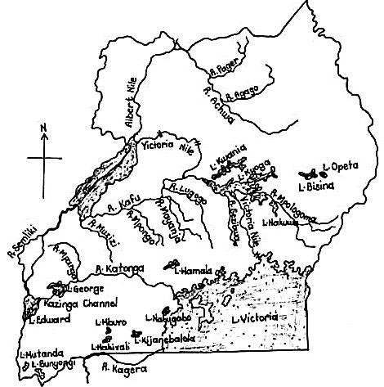

- Activities carried out on and around lakes and rivers.
Fishing. ❖ Crop growing ❖ Tourism  Transportation. ❖ Trading. ❖ Industrialization.
- Importance of lakes and rivers
They act as fishing grounds.
Rivers help in generation of hydro electricity.
They attract tourists who bring in income.
They are homes for aquatic animals.
They form natural boundaries between countries.
They provide water for irrigation, domestic and industrial use.
They help in rainfall formation
- MINI ACTIVITY
1. Give any two economic activities done on rivers
i) ____________________________________ ii) __________________________________
2. Mention any two economic activities carried out near lakes and rivers
i) _____________________________________ ii) _________________________________
3. State the political importance of some rivers to Uganda
_________________________________________________________________________

4. How are rivers useful to aquatic animals?
_________________________________________________________________________
5. Why should the government of Uganda protect rivers and lakes?
_________________________________________________________________________
KEY LEARNING PRINCIPLES
Navigable- used for transport
PROJECT WOK
Locate all the major rivers in Uganda on a map and display it in your classroom after
being approved by your teacher.
List down the competences that have been hard for you
1
2
3
4
5
6
7
8

MEGA ACTIVITY
1. Give the meaning of a river
___________________________________________________________________________
2. Why are rivers regarded as drainage features?
___________________________________________________________________________
3. Give any two reasons why some parts of rivers are not navigable
i) _________________________________________________________________________
ii) _________________________________________________________________________
4. How is tourism promoted in Uganda through the use of lakes and rivers?
___________________________________________________________________________
5. How do we call a point where a river ends its flow?
___________________________________________________________________________
6. Where does river semliki end its flow?
___________________________________________________________________________
7. How are lakes and rivers socially important to people?
___________________________________________________________________________
8. Of what use are rivers to industries of Uganda?
___________________________________________________________________________
9. Give any two ways how the government can protect lakes and rivers from siltation
i) _________________________________________________________________________
ii) ________________________________________________________________________
10. What is the main cause of water hyacinth on some lakes of Uganda?
___________________________________________________________________________
SESSION 8
CONVECTIONAL RAINFALL
RELEVANCE: To enable the learner explain the process of convectional rainfall and the conditions necessary for its occurrence.
- INTRODUCTION
In the previous session we were able to learn about
Description of rivers
Activities carried out on and around lakes and rivers
The importance of lakes and rivers
- COMPETENCES
- Illustrates the formation of convectional rainfall
- Explains problems associated with lakes and rivers
- Explains problems facing lakes and rivers
- Explains why some parts of rivers in Uganda are not navigable
- Explains why lake shores and river banks are densely populated
- CONTENT
- Convectional rainfall
This is the type of rainfall received around water bodies and large forests
- PROCESSES
Evaporation> is the process by which the sun heats a water body to form water vapor
Condensation>is the process by which water vapor changes into clouds in the atmosphere
Transpiration>is the process by which plants loose excess water in form of water vapor
Precipitation>is the process by which clouds change into water droplets to form rainfall.
A diagram showing the formation of Convectional rainfall.
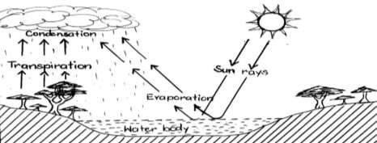

MINI ACTIVITY
1. Define the following terms
i) Condensation ____________________________________________________________
ii) Evaporation ____________________________________________________________
2. How are the following helpful in the formation of convectional rainfall?
i) The sun __________________________________________________________________
ii) Water body______________________________________________________________
iii) Plants __________________________________________________________________
- Problems associated with lakes and rivers.
- Drowning  They harbor disease vectors.  Flooding  Rivers and lakes hinder road and They harbor dangerous aquatic railway construction. animals.
- Problems facing lakes and rivers
- Silting which reduces the depth of water bodies.
- Overuse of water from lakes and rivers for irrigation.
- Drought which lowers the water level.
- Dumping of wastes into water bodies.
- Over fishing
- Why some parts of rivers in Uganda are not navigable (not used for for transport)
- Some rivers have waterfalls and rapids.
- Some parts of rivers are shallow and narrow
- Some rivers have dangerous aquatic animals.
- Some rivers have floating vegetation. (suds)
- Reasons why lake shores and river banks are densely populated.
- They have fertile soils for crop growing.
- They receive reliable rainfall.
- They have a lot of employment opportunities.
- MINI ACTIVITY
1. Give any two reasons why lake shores are densely populated 2. State any two problems associated with lakes and rivers
2. What do you understand by water hyacinth?
3. Outline any two problems associated with people living near lakes and rivers
4. Give any two examples of dangerous aquatic animals that hinder navigation on water.
- KEY LEARNING PRINCIPLES
Suds> The vegetation that floats or grows on water (water hyacinth) Navigable>used for transport.

List the competences that have been hard for you
1
2
3
4
5
6
7
8

- MEGA ACTIVITY
1. Mention any two problems associated with lakes and rivers.
i) __________________________________________________________________________
ii) __________________________________________________________________________
2. Give any two places in Uganda which receive convectional rainfall
i) ______________________________________ ii) _________________________________
3. Why do the above areas receive convectional rainfall?
____________________________________________________________________________
4. Outline any two processes that involve in the formation of convectional rainfall
i) ____________________________________ ii) ___________________________________
5. Mention any one factor that lead to disease vectors on lakes and rivers
____________________________________________________________________________
6. How can we overcome the problems associated with lakes and rivers?
____________________________________________________________________________
7. How do factories influence lakes and rivers?
____________________________________________________________________________
8. What do you understand by the term precipitation?
____________________________________________________________________________
9. Which type of clouds give us rainfall?
____________________________________________________________________________
10. What measures has the government put to control over fishing?
____________________________________________________________________________

SESSION 19
THE INFLUENCE OF PHYSICAL FEATURES
RELEVANCY: To enable the learner explain how physical features influence human
activities settlement patterns and the economy in Uganda
- INTRODUCTION
In this session we are going to learn about,
- The influence of physical features on people
- Factors which attract human settlement in plateaus and highland areas
- Economic activities carried out in highland areas
- Reasons why there are few people living in higher parts of mountains
- CONTENT
- THE INFLUENCE OF PHYSICAL FEATURES
a) On People
The wind ward side of a mountain attracts very many people due to the presence of fertile soils for cultivation, and also receives plenty of rainfall.
The lee ward side of a mountain has very few people because it receives very little rainfall.
Plains favor pastoralism due to the presence of pasture.
Road and railway transport is poor in highland areas due to the presence of steep slopes.
Many people settle around lakes and rivers because such areas receive reliable rainfall and have fertile soils which support crop cultivation.
- Factors which attract human settlement in;
i) Plateau areas
- Presence of pasture for animals.
- Agricultural mechanization is easy in such areas.
- Construction of houses, roads, railways and industries is easy.
- Natural hazards like floods are not common in these areas.
ii) Highland areas
❖ Presence of fertile soils. ❖ Availability of reliable rainfall.
- Common economic activities carried out in highland areas.
- Crop farming • Mining Dairy farming
- Reasons why there are very few people living in higher parts of mountains.
- Transport is poor in higher parts of the mountains
- Highland areas experience very low temperatures which do not favor human settlement.
- MINI ACTIVITY
1. What do you understand by a highland?
__________________________________________________________________________
2. How do highland areas influence the settlement of people?
___________________________________________________________________________
3. Give any two examples of economic activities that are carried out in highland areas
i) _______________________________________ ii) _______________________________
4. Why do highland areas receive low temperatures?
___________________________________________________________________________
5. Mention any one way how physical features influence people.
___________________________________________________________________________
- KEY LEARNING PRINCIPLES
Mining is the extraction of minerals from where they occur
A highland is a raised piece of land
Plateau is a flat-topped raised piece of land
List down the competences which have been hard for you
1
2
3
4
5
6
7
8

MEGA ACTIVITY
1. Name the two sides of a mountain
i) __________________________________ ii) ____________________________________
2. Which side of a mountain receives little or no rainfall?
___________________________________________________________________________
3. Why does that side receive little or no rainfall?
___________________________________________________________________________
4. How is a mountain useful in the formation of relief rainfall?
___________________________________________________________________________
5. Give any two factors that attract human settlement
i) ______________________________________ ii) ________________________________
6. How do the above factors attract human settlement?
__________________________________________________________________________
7. Give the meaning of a plateau
__________________________________________________________________________
8. Name the largest plateau in Uganda
__________________________________________________________________________
9. Give any two examples of natural hazards that may lead to displacement of people in an area
i) _______________________________________ ii) ______________________________
10. How can the above hazards be controlled?
__________________________________________________________________________
SESSION 20:
THE INFLUENCE OF PHYSICAL FEATURES ON
PLANTS, ANIMALS AND CLIMATE
Relevancy: To enable the learner explain how physical features influence on plants, animals and climate
- INTRODUCTION
In this session we are going to learn about the following
- The influence of physical features on plants
- The influence of physical features on animals
- The influence of physical features on climate
- COMPETENCES
- Describes the influence of physical features on plants
- Describes the influence of physical features on animals
- Describes the influence of physical features on climate
- CONTENT
- The influence of physical features on Plants
Areas around lakes and rivers have many plants due to plenty of rainfall received.
Slopes of mountains have forests due to presence of fertile soils and reliable rainfall
received.
Mountain tops have few plants due to low temperatures and bare rocks.
- The influence of physical features on Animals.
Plains have plenty of grass which attracts wild animals.
Water bodies favour aquatic animals.
Pastoralism in common on plateau areas due to the presence of pasture for animals.
There are many climbing animals eg. mountain gorillas in highlands due to the presence
of many fruit trees.
- The influence of physical features on Climate.
- Mountains receive plenty of relief rainfall.
- The wind ward side of a mountain receives plenty of rainfall because it receives warm
- moist air.

- The lee ward side of the mountain receives very little rainfall because it receives dry
- winds.
- Mountainous areas experience very low temperatures because they lie at a higher
- altitude.
- Rift valleys and low lands experience very high temperature because they are of low
- altitude.
- Lake shores receive plenty of convectional rainfall.
MINI ACTIVITY
1. Give the meaning of the term climate
____________________________________________________________________________
2. Why do mountainous areas receive low temperatures?
___________________________________________________________________________
3. Why are lake shores densely populated?
___________________________________________________________________________4. How do physical features influence on plants in an area?
___________________________________________________________________________
KEY LEARNING PRINCIPLES
Altitude> height above the sea level
Plains> flat areas
List down the competences that have been hard for you
1
2
3
4
5
6
7
8
MEGA ACTIVITY
1. Which factor attracts animals to live on the plains of Uganda?
___________________________________________________________________________
2. Which type of rainfall is received in mountainous areas?
___________________________________________________________________________
3. Name the side of a mountain that favors human settlement
___________________________________________________________________________
4. Why does the above side promote human settlement?
___________________________________________________________________________
5. Give any two areas in Uganda that experience hot temperatures
i) _______________________________________ ii) _______________________________
6. Why do the above areas have hot temperatures?
___________________________________________________________________________
7. How do lakes and rivers modify the climate of an area?
___________________________________________________________________________
8. Define pastoralism
___________________________________________________________________________
9. Give any two factors that lead to pastoralism
i) ______________________________________ ii) _________________________________
10. Why are slopes of mountains densely populated?
___________________________________________________________________________
PROJECT WORK
Draw a sketch map of Uganda and locate the major physical features on it and get
the cut out of the map.

